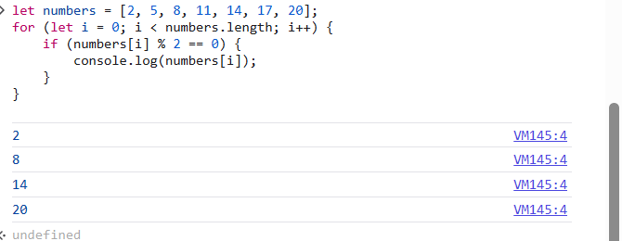

* Given an array of strings, find the longest string and print it.

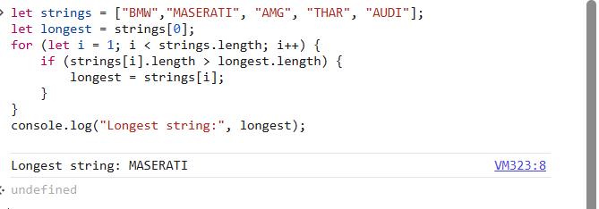

Given a number n, print all odd numbers from 1 to n using a while loop

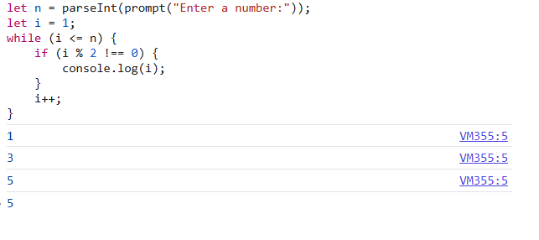

* Implement a loo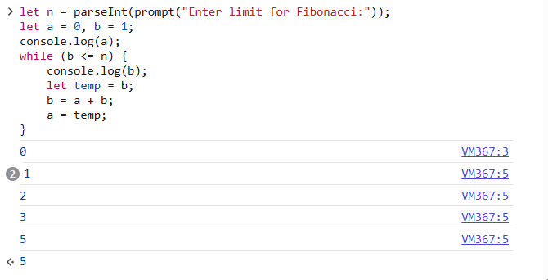p that prints Fibonacci numbers up to a given number n.